Building separate module testing in PlatformIO

When a subset of packets are changed and needs to be tested you do not want to have to test them immediately on the full vechicle both from an integration challenge, but also the extra complexity of testing something that is moving around on the floor. Therefore this document describes how to compile and upload subsets of the code.
PlatformIO has something called Environments that we can use for this purpose. When in the PlatformIO window, you can see the current Environment in the middled of the bottom window frame. By clicking it you can select one of the other environments.

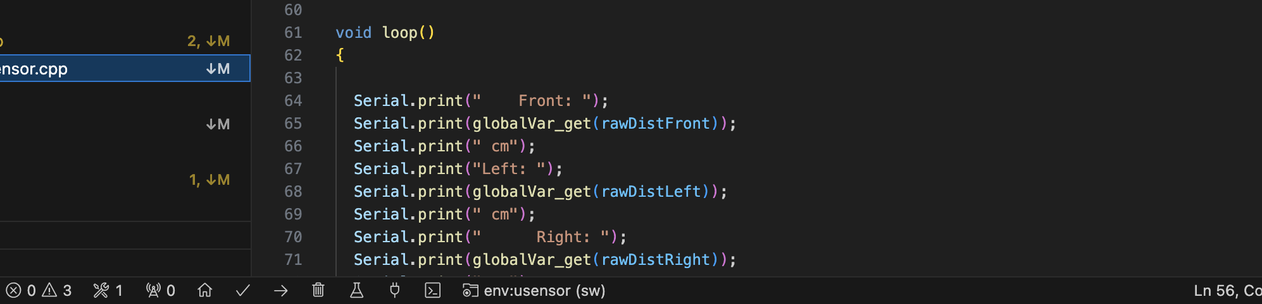
In this example the env:usensor is selected

You add and edit environments in the platformio.ini file

Key parameters in the PlatformIO.ini are
- [] within square brackets you can define a new environment starting with env:
  - Example: [env:usensor]
- the platform, board and framework is the same as for the default, just copy them
  - Example: platform = espressif32@3.5.0
board = esp32dev
framework = arduino
- build_flags allow you to add flags to your build process, the -v means verbose which could be useful if you have strange problems
  - Example:build_flags = -v
- build_src_filter is essential to avoid identifier/file collisions like trying to compile more than one main.cpp (resulting in several setup() and loop() functions). The trick is to filter out ALL cpp files using -<*.cpp>, then include the specific files you want included in your build: +<filename.cpp> .
  - Example: build_src_filter = -<*.cpp> +<z_main_usensor.cpp> +<setget.cpp> +<usensor.cpp>
- monitor_speed is the speed if the serial line used for the Serial.print from the esp32. The default is 9600 which usually too slow, so we have decided to standardise on 57600 which in most cases are fast enough without risking loosing characters. It is important this speed matches the speed you have in your setup() of Serial, if you are using it at all
  - Example: monitor_speed = 57600
  - Example from your main:
void setup() {
// Initialize serial communication for debugging
Serial.begin(57600);

Example of the environment as defined in platformio.ini
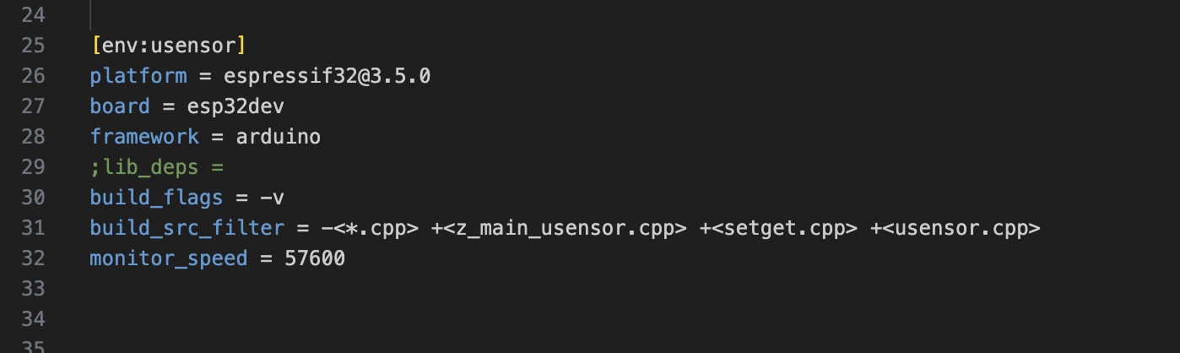
main.cpp should NOT be used for testing of separate parts. Instead you need to write a separate main for the tests. Not to mess up the source directory we have decided they should all start with z_main_nnnn. This ensures they end up at the end of the source list so it is still easy to see which are the available .cpp files for the project.

